Project Development Phase
Performance Test

Date | 21 February 2026
Team ID | LTVIP2026TMIDS41475
Project Name | Intelligent SQL Querying with LLMs using Gemini Pro
Maximum Marks

Model Performance Testing:

S.No. | Parameter | Screenshot / Values
 | Data Rendered | 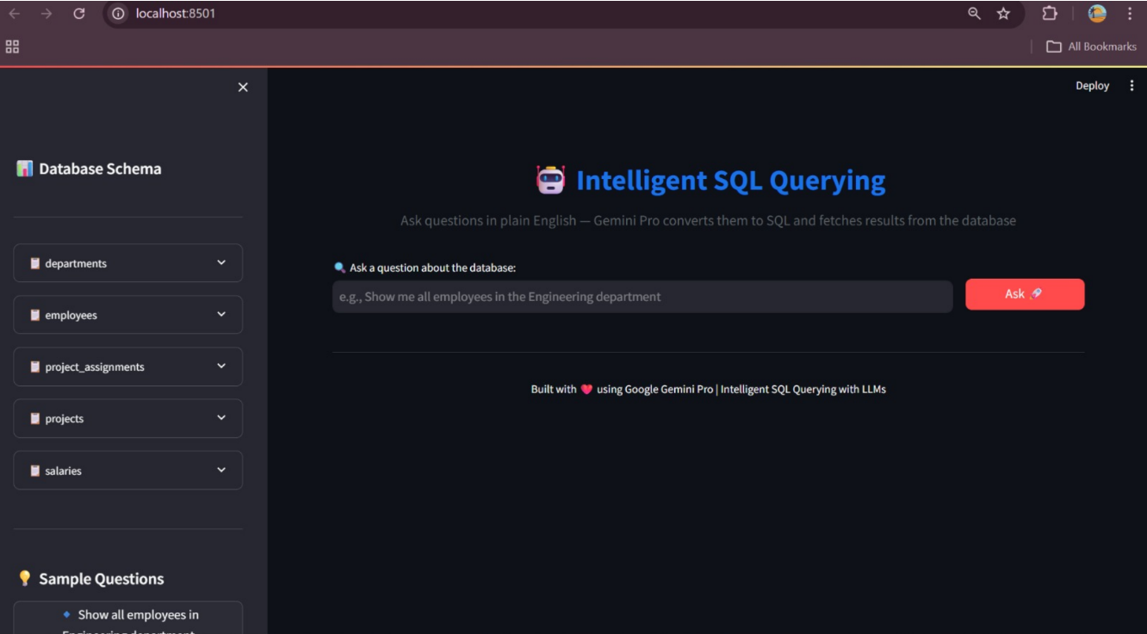
 | Data Preprocessing | 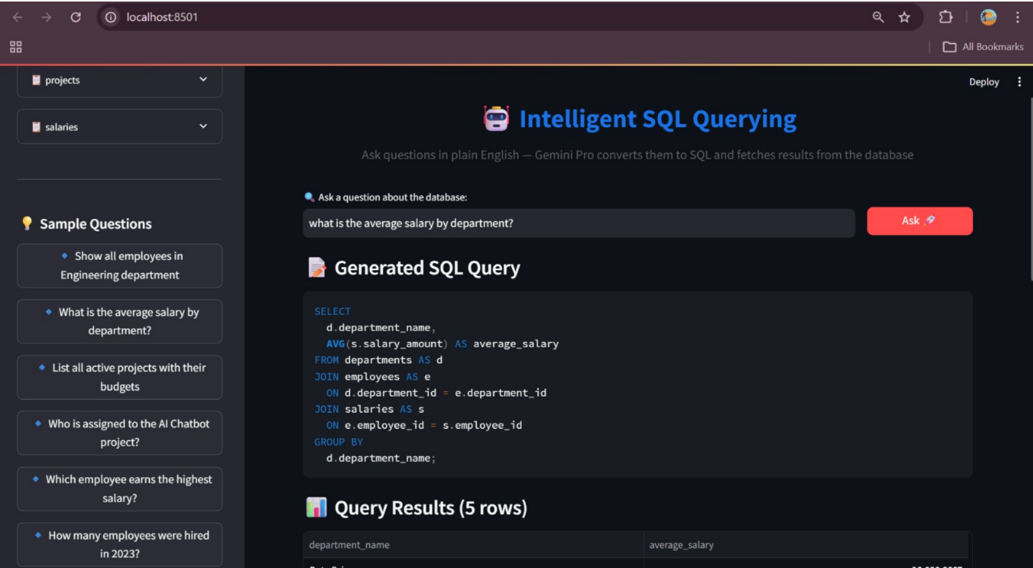
3. | Utilization of Filters | 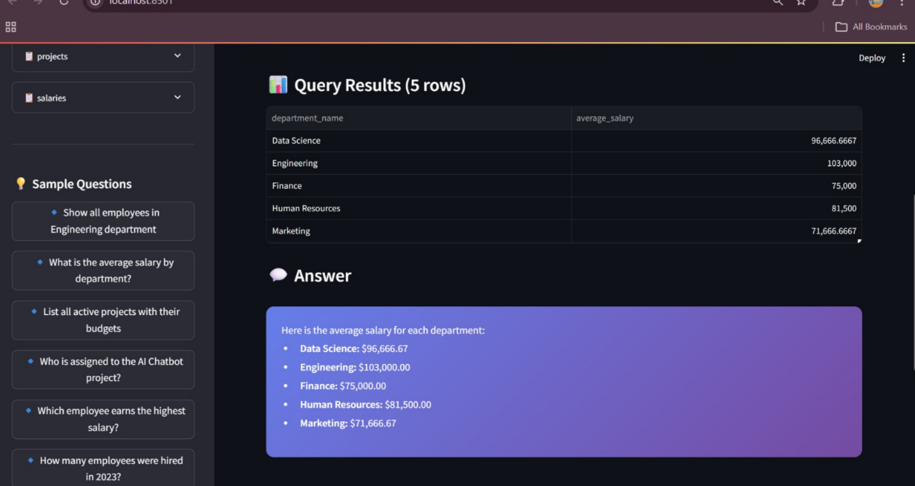
4. | Calculation fields Used | 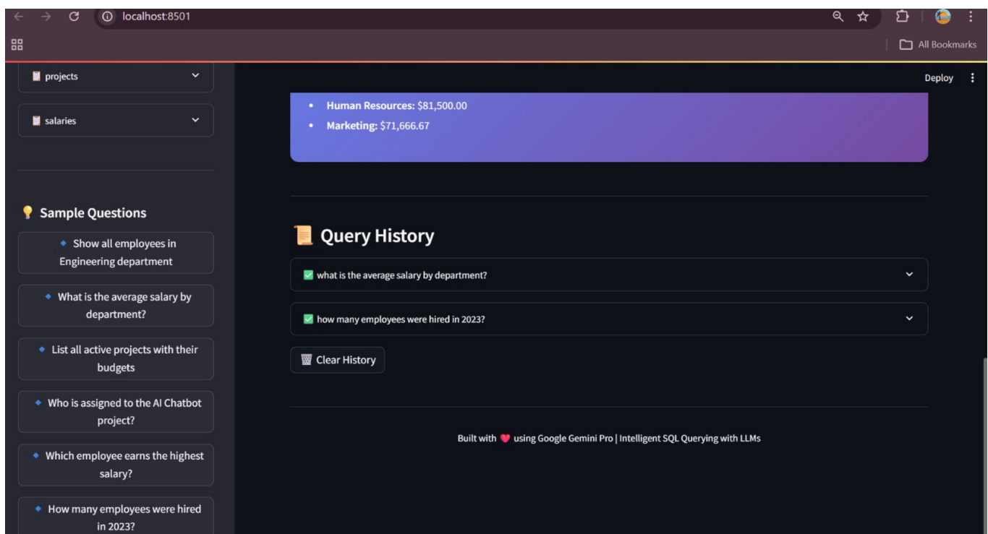
5. | Dashboard design | No of Visualizations / Graphs -
6 | Story Design | No of Visualizations / Graphs -

